# **CHAPTER ONE**

**INTRODUCTION AND LITERATURE REVIEW**

# **1.1 INTRODUCTION**

Crude oil pollution is one of the most common types of environmental pollution today. The developments in science though positive but it has also lead to various kinds of environmental dilapidation and have not yet been fully evaluated. Due to the technological progression in the world today, there have been major concerns over the level of pollution (carbon) we create. Crude oil pollution is the most popular contaminant when considering land and water pollution.

Pollution according to Onajoke, (2004) is the introduction of harmful substances into the environment that risks human health and other natural resources. Tanee and Anyanwu, (2007) defined Crude oil pollution as the introduction of crude oil or its by-products with its associated gases into the environment in quantities that are poisonous or capable of causing immediate physical, chemical and biological changes to the affected ecosystem. One of the environmental challenges posed by this oil pollution is the alteration in the physical, chemical and biological nature of soil which subsequently affects the growth of plants (Tanee & Akonye, 2009). The spillage of crude oil on land affects the soil properties, which causes poisonous effects on the plant growth and possibly nutrients.

These hydrocarbons lead to the presence of heavy metals and other unwanted components in the soil thereby degrading the soils fertility and its potentials. The alteration in the biological, chemical and physical properties of the soil, water or air have detrimentally affected the health, survival and actions of humans or organisms (Nyananyo, 2008). Thus, the high need for remediation of polluted sites to remediate or improve the soil fertility and the performance of crops in the polluted areas.

This study is to investigate the growth performance of sorghum (*sorghum bicolor*) (NG/AA/Sep/09/160) in a crude oil polluted soil amended with N.P.K(20-10-10). The expected result from this study will hopefully show the effects of crude oil contamination on crops (sorghum) and if N.P.K can be used to improve the crop performance.

# **1.2 LITERATURE REVIEW**

# **1.2.1 SCIENTIFIC CLASSIFICATION OF SORGHUM**

**Scientific Classification**

Kingdom Plantae

Division Angiosperms

Order Poales

Family Poaceae

Subfamily Panicoideae

Genus Sorghum

Specie *Sorghum bicolor*

Authority (L) Moench (Carl Linnaeus and Conrad Moench)

*Sorghum bicolor*, commonly called sorghum also known as great millet, durra, jowari or milo, is a species cultivated for its grain, which is used for food for humans, animal feed, and ethanol production. Sorghum originated in Africa and is now cultivated widely in tropical and subtropical regions. Sorghum is the world's fifth-most important cereal crop after rice, wheat, maize and barley. *S. bicolor* is typically an annual, but some cultivars are perennial. It grows in clumps that may reach over 4 m high. The grain is small, ranging from 2 to 4 mm in diameter. Sweet sorghums are sorghum cultivars that are primarily grown for foliage, syrup production and ethanol; they are taller than those grown for grain.

*Sorghum bicolor* is the cultivated species of sorghum; its wild relatives make up the botanical genus Sorghum.

# **1.2.2 CULTIVATION OF SORGHUM**

The leading producers of *sorghum bicolor* in 2011 were Nigeria (12.6%), India (11.2%), Mexico (11.2%), and the United States (10.0%) (Stroade *et, al., 2005*). Sorghum grows in a wide range of temperature (seeds germination at 7-100c and good growth at 26-300c), high altitudes of 2300m, toxic soils and can recover growth after some drought. It has four features that make it one of the most drought-resistant crops: (Grassland Index)

* It has a very large root-to-leaf surface area ratio.
* In times of drought, it will roll its leaves to lessen water loss by transpiration.
* If drought continues, it will go into dormancy rather than dying.
* Its leaves are protected by a waxy cuticle.

In 19th-century Ethiopia, sorghum was "often the first crop sown on newly cultivated land", explaining that this cereal did not require the thorough ploughing other crops did, and its roots not only decomposed into a good fertilizer, but they also helped to break up the soil while not exhausting the subsoil (Richard Pankhurst 1968).

# **1.2.3 USES**

Sorghum is cultivated in many parts of the world today. In the past 50 years, the area planted with sorghum worldwide had increased 66%. In many parts of Asia and Africa, its grain is used to make flat breads that form the staple food of many cultures.

The grains can also be popped in a similar fashion to popcorn.

The species can be used as a source for making ethanol fuel, and in some environments may be better than maize or sugarcane, as it can grow under harsher conditions.

It typically has protein levels around 9%, enabling dependent human populations to subsist on it in times of famine, in contrast to regions where maize has become the staple crop. It is also used for making traditional corn broom (Ogden Publications 2010).

The reclaimed stalks of the sorghum plant are used to make a decorative millwork material marketed as Kirei board.

Sweet sorghum syrup is known as molasses in some parts of the U.S, although it is not true molasses.

In China, sorghum is known as gaoliang, and is fermented and distilled to produce one form of clear spirits known as baijiu of which the most famous is Maotai (or Moutai).

Sorghum was ground, and the flour was the main alternative to wheat in northern China for a long time.

In India, where it is commonly called jwaarie, jowar, jola or jondhalaa, sorghum is one of the staple sources of nutrition. An Indian bread called bhakri, jowar rot or jolada rotti, is prepared from this grain.

In some countries, sweet sorghum stalks are used for producing biofuel by squeezing the juice and then fermenting it into ethanol (agribusinessweek.com 2008). Texas A&M University in the United States is currently running trials to find the best varieties for ethanol production from sorghum leaves and stalks in the USA.

In Taiwan, the island calls Kinmen plain *sorghum bicolor* and made into white wine, the wine called sorghum liquor.

In Korea, it is cooked with rice, or its flour is used to make cake called susu bukkumi.

In Australia, South America, and the United States, sorghum grain is used primarily for livestock feed and in a growing number of ethanol plants (United Sorghum Checkoff Program).

In Central America, tortillas are sometimes made using sorghum. Although corn is the preferred grain for making tortillas, sorghum is widely used and is well accepted in Honduras. White sorghum is preferred for making tortillas.

In several countries in Africa, including Zimbabwe, Burundi, Mali, Burkina Faso and Ghana sorghum of both the red and white varieties is used to make traditional opaque beer. Red sorghum imparts a pinkish-brown color to the beer. Sorghum is one of several grains used as wheat substitutes in gluten-free recipes and products.

It is used in feed and pasturage for livestock. Its use is limited, however, because the starch and protein in sorghum is more difficult for animals to digest than the starches and protein in corn. Research is being done to find a process that will predigest the grain. One study on cattle showed that steam-flaked sorghum was preferable to dry-rolled sorghum because it improved daily weight gain. In hogs(pigs), sorghum has been shown to be a more efficient feed choice than corn when both grains were processed in the same way.

The introduction of improved varieties, along with improved management practices, has helped to increase sorghum productivity. In India, productivity increases are thought to have freed up six million hectares of land. The International Crops Research Institute for the Semi-Arid Tropics (ICRISAT) in collaboration with partners produces improved varieties of crops including sorghum. Some 194 improved cultivars of sorghum from the institute have been released.

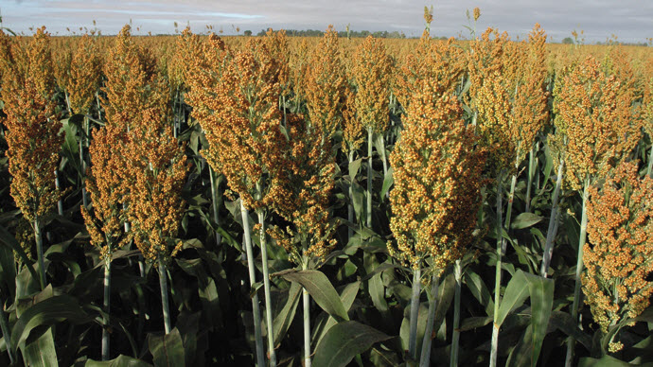

# **Fig 1:** Field of *Sorghum bicolor* plant

www.google.com

# **1.2.4 STANDARD-COLOR OF *SORGHUM BICOLOR***

Genetics of pericarp color, pericarp thickness, presence or absence of a testa and testa color and thickness influences grain color. Pericarp thickness influences seed color and may range from white to pink, orange, red and brown (Bryan 2016)

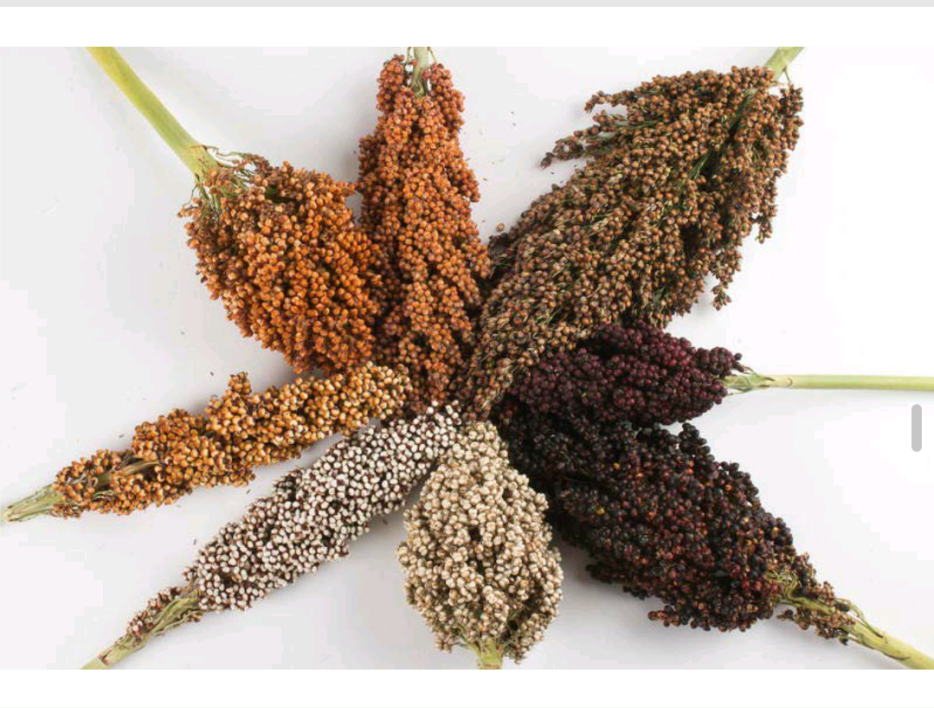

# **Fig 2:** Standard Colors of *sorghum bicolor.*

# Source www.google.com

# **1.2.5 PESTS AND DISEASES**

Sorghum is a host of the parasitic pest *Striga hermonthica*. This parasite is a devastating pest on the crop. The European corn borer (*Ostrinia nubilalis*) was introduced to North America via transport of infested Sorghum broom corn.

# **1.3 EFFECTS OF CRUDE OIL POLLUTANT ON SOIL**

Oil spill is said to be the release of petroleum hydrocarbons into the environment due to human or technical errors caused by human interactions with the environment. Oil released into the oceans or coastal waters is often termed as “marine oil spillage”.

Oil spills includes the release of crude oil from tankers, offshore rigs, drilling rigs and wells, as well as spills of refined petroleum products (gasoline, DPK, diesel, etc) and their byproducts and heavier fuels used by large ships such as bunker fuel or spills from any oily refuse or waste oil (Nzerem, 2014).

When crude oil is accidentally discharged for various reasons ranging from failure of production equipment to operational mishaps or intentional damage to production facilities, it inevitably inundates the soil, a prime factor in agricultural productivity and major source of livelihood in the oil producing communities (Osuji *et al.*, 2005).

In environments that are completely aquatic, oil sometimes floats on water surfaces where it is dispersed to shorelines by wind and wave actions, eventually affecting the soil environment. Since most of the terrestrial ecosystems and shorelines in the oil producing communities are important agricultural lands and are under continuous cultivation. Hence, any contact with oil may result in the damage of soil properties and plants in these communities (Amadi *et al.,* 1993). Nwankwo and ifeadi, 1988 stated that beyond 3% oil concentration in the soil is found to be toxic to soil biota and crop growth, this spilled oil may sometimes also form serious bushfire that may consume several acres of arable land. According to Osuji *et al.,* 2005 cleanup measures are usually done as part of the oil spillage contingency programme, petroleum hydrocarbon have been found to stick to surface and subsurface soils long after such cleanup activities, hence impairing agricultural productivity.

The effects of crude oil pollution on the properties of soil have been the subject of many studies (Okolo *et al.*, 2005) reported that oil pollution increases soil organic carbon and reduced soil nitrates and phosphorous, hence imposing a condition that impaired degradation in the soil. It is the base of Nigeria’s oil and gas industry, generating over 90% of the country’s economy. According to Ngobire *et al.,* 2007 oil exploration and activities have been concentrated in this Niger-Delta region (eleme) which have over 1000 production wells and over 47,000 km of oil and gas flow lines. The exploration which brought about a negative impact of the oil activities which includes destruction of wildlife, loss of fertile soil, pollution of air and water ways and damage to the ecosystem of the host communities. Brownish vegetations, infertility of fertile lands, soil erosion, diminishing resources of the natural ecosystem, adverse effects on life, health and economy of the people, these are some of the ecological problems observed because of oil spill (Roberts, 1997).

According to Oyem, 2001, the major cause of oil spills in Nigeria today is lack of conservation of pipelines and storage tanks. Some of these pipelines are over 20 years old which makes them susceptible to deterioration and leakages. Some of these pipes which were placed above ground without proper maintenance and surveillance leaving them exposed to wear and tear and other dangers like vandalism by terrorists or unpatriotic civilians.

During the 40 years of oil exploration in Nigeria, over 60,000 spills have occurred, between 1976 and 1996 2.4×10 barrels of crude oil spills from 647 incidents have occurred only 54,706,038 barrels were recovered; thus 182,040,666 barrels were lost to the ecosystem (Petroleum resource annual report, Abuja 1997). The growth of oil industry joint with population flareup and a lack of environmental guidelines have caused extensive damage to the environment of the Niger-Delta. Subsequent years of ignoring or giving little or no attention to the hostile effect of oil spill, the Nigerian government has begun to take steps to mitigate the damage. The role of the environmental agency in checking and documenting oil-spills is getting stronger as the new upsurge of combating oil spill through phytoremediation is intensely unfolding in the remediation industry. Although several studies have been commissioned by oil companies on the socio-economic effects of their operations in the host communities, independent studies on the environmental impacts of oil spill have been scarce.

# **1.4 AIM OF STUDY**

The main purpose of this work is to show the effect of crude oil on *Sorghum bicolor* amended with N.P.K fertilizer (20-10-10) for the growth and development of the plant.

# **1.5 OBJECTIVES OF THE STUDY**

The objectives of the study are:

1. To evaluate the effect of crude oil pollution on the growth and yield of sorghum.
2. To determine the heavy metal contents of sorghum grown on crude oil polluted soil.

# 

# **CHAPTER TWO**

# **2.1 MATERIALS AND METHODS**

# **2.2 Study Area**

This study was conducted at the university of Port Harcourt, Choba, which is located on latitude 4֯ 53’ 14” N through 4֯ 54’ 42” N and longitude 6֯ 54’ 00” E through 6֯ 55’ 50” E. My experiment was done at the University of Port Harcourt Green House.

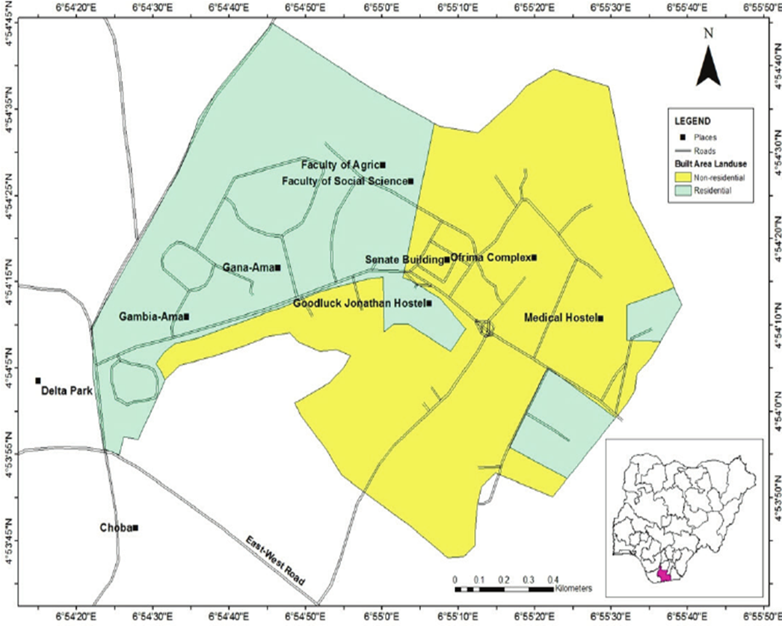

# **Figure. 3:** Map of University Park, University of Port Harcourt

# **Source:** www.google.com

# **2.3 SOURCES OF MATERIALS**

Soil samples were obtained beside the University’s Faculty of Agricultural science Farm house. The seeds of *Sorghum bicolor* NG/AA/Sep/09/160 variety were sourced from The National Centre for Genetic Resources and Biotechnology (NAGRAB) Ibadan and N:P:K (20-10-10) was purchased from an agricultural products store and sack bag were purchased from the market, while the crude oil was obtained from Ogoni, Rivers State.

# **2.4 EXPERIMENTAL DESIGN**

The sack bags were arranged in completely randomized design with each bag weighting an average of 20.34kg.

The experiment carried out was completely Randomized Design (C.R.D) of five(5) treatments and four(4) replicates making it a total of 20 bags.

Measuring cylinder calibrated in milliliters was used to measure the concentration of crude oil; 0% (control), 0%, 2%, 4% and 8% V/W.

T0- control

T1- 0% of crude oil + amendment

T2- 2% of crude oil + amendment

T3- 4% of crude oil + amendment

T4- 8% crude oil + amendment

# **2.5 CONTAMINATION AND AMENDMENT OF THE SOIL**

The soil was contaminated with crude oil in different concentrations with five (5) treatments including control used in 25 sack bags and amended with N:P:K (3.05g/bag).

The soil was thoroughly mixed after contamination and left for 3weeks before N:P:K was applied and left again for 2weeks before planting.

# **2.6 PLANTING OF SEEDS**

After decomposition of the N:P:K, the seeds of *Sorghum bicolor* were planted with seven (7) seeds per bag. After a week of planting, most of the seeds started to sprout, and measurements were taken from week two (2).

# **2.7 SOIL ANALYSIS**

Two (2) weeks after contamination soil analysis was done, before treatment for remediation to discover the physiochemical and microbial nature of the soil.

# **2.7.1 Determining Soil pH**

**Procedure**

Soil pH in H2O (1:1)

10g of sample was weighed into an extraction cup, 10mls of distilled water was add to it and left to stand for about 15 minutes. The mixture was then placed in a mechanical shaker for 30minutes at 150 rpm and allowed to sit for 10 minutes. A pH meter is then calibrated using buffers 7.0 and 4.0 then d pH value was recorded from the pH meter.

Soil pH in .01M CaCl2 (1:1)

After the pH was recorded, one drop of 1M CaCl2 solution was added to the soil water suspension and stirred for about 15 minutes and let to stand for about 25 minutes. Then the pH value of the sample on the pH meter was recorded and calibrate with buffers 7.0 and 4.0.

Soil pH in 1M Kcl (1:1)

Same procedure for soil pH (H2O) was used but substituted 1M Kcl for H2O.

# **2.7.2 PHYSIOCHEMICAL PROPERTIES OF THE SOIL**

The following tests were carried out as show below (Table 1).

# **2.7.3 DETERMINATION OF AVAILABLE PHOSPHORUS**

**Apparatus:** Weighing balance, mechanical shaker, centrifuge tube, spectrometer.

**Procedure:** 5g of air – dry soil (2mm sieved) was weighed in an extraction cup and 30ml Bray-1 solution was added into it. The solution was stirred using a mechanical shaker for 5 minutes and let to stand for about 2minutes and then centrifuged for 5 minutes at 3000rpm. Pipette 1ml of the clear supernatant was put into a set f clean glass vials and 6ml of distilled water was added and mixed well. 2ml of colour reagent was then added and mixed well, after 6 minutes, the colour was measured at 650nm on a colorimeter or a visible range spectrophotometer.

# **2.7.4 DETERMINATION OF EXCHANGEABLE ACIDITY (Al + H) AND ALUMINIUM USING TITRATION METHOD**

**Procedure:**  3g of air-dried soil (grind to pass a 2mm sieve) was weighed into a filter paper and placed on the extraction cups. 50ml of 1.0N Kcl solution was gently poured through the soil in the filter paper and collected the leachate. 5 drops of phenolphthalein indicator were added in the leachate and titrated the leachate with 0.05N NaOH to pink end point and the volume (ml) of NaOH used (v) was recorded.

# **2.7.5 DETERMINATION OF ORGANIC CARBON IN THE SOIL**

**Procedure:** A sample and grinded and passed through 0.5mm sieve and weighed out soil samples in duplicate and transfer to 250ml Erlenmeyer flask. A Pipette of 10ml of 1N K2Cr2O7 solution was put accurately into each flask and swirlled gently and dispense the soil. 20ml concentration H2SO4 was added rapidly using an automatic pipette directing the stream into the suspension. 100ml of distilled water was added after standing for 30 minutes. 3 – 4 drops of indicator and titrate with 0.5N ferrous sulfate solution was added. The solution then takes on a greenish cast and then changes to dark green.

# **2.7.7 DETERMINATION OF TOTAL NITROGEN AND PHOSPHORUS IN PLANTS AND SOIL**

**Procedure:** 0.3 +/- 0.001g of oven dried (700) was weighed, the plant tissue was grounded into a labelled, dried and clean digestion tube. 2.5ml digestion mixture was added to each tube and the reagent blanks for each batch of sample and digested at 1100c for one hour and removed, cooled and added with 3 successive 1ml portions of hydrogen peroxide. The temperature was raised to 3300c and continued heating and allowed cool. About 25ml distilled water was added and mixed well until no more sediment dissolved. It was then allowed to cool and make up to 50ml with water.

# **2.7.8 DETERMINATION OF TOTAL NITROGEN**

**Procedure:** A steam distillation apparatus was set up and NH3 free distilled water was used wherever possible. An aliquot of sample solution was transferred to the reaction chamber of the still and added 10ml of 1% boric acid containing 4 drops of the mixed indicator. Distillation continued about for 2 minutes from the time the indicator turns green. Then steam was passed through the apparatus for about 30minn and the distillation recovery was occasionally checked if satisfactory by taking an aliquot (5.0ml) of the standard ammonium sulphate solution in place of the sample.

# **2.7.9 HEAVY METAL ANALYSIS**

# **2.7.9.1 PROCEDURES FOR ZINC**

The instrument was energized. Wavelength of 213.8nm is recommended for zinc. Air and Acetylene gas flow slit width were adjusted. Other essential settings recommended for efficiency for the instrument employed were adjusted. Hollow cathode lamp was given adequate time to stabilize. Standard zinc solution of known concentration was aspirated into the burner chamber and the corresponding absorbance were recorded. Instrument system was flushed with de-ionized water. the test sample was aspirated, and its absorbance was obtained. The concentration of zinc in the sample was interpolated from the standard zinc graph.

# **2.7.9.2 PROCEDURE FOR LEAD (Pb)**

Lead ion was analysed by an Atomic Absorption Spectrophotometer at 283.3nm wavelength was selected with a narrow slit with air and acetylene gas flow was adjusted. Other setting as recommended for the instrument employed was attended to and regulated. Hallow cathode lamp was given adequate time to stabilized before aspirating standards for equipment calibration. After calibrating the equipment with standard lead concentrations, the aspiration tubing and system were flushed with distilled water severally before aspirating the test sample solution on the sample experimental condition used for the standard.

The concentration of Lead ion in the sample was extrapolated from the standard graph of lead ion plotted. The concentration was expressed in mg/l or ppm fromz the equipment corrections were made necessary in units of choice.

# **2.8 SOIL MICROBIAL TEST**

This test was carried out by the University of Port Harcourt Department of Microbiology. Analysis carried out were; Isolation and Enumeration of Total Heterotrophic Bacteria (THB), Total Fungi (TF), Hydrocarbon Utilizing Bacteria (HUB), Hydrocarbon Utilizing Fungi (HUF).

# **2.8.1 PROCEDURES FOR MICROBIOLOGICAL ANALYSIS**

**TOTAL HETEROTROPHIC BACTERIA (THB)**

1g of soil sample was weighed into 9ml sterile diluent (0.85% NaCl) under aseptic condition. It is then agitated vigorously to homogenize and serially diluted. Then 0.1ml aliquot of the inoculums was collected using a sterile pipette, inoculated on Nutrient Agar (NA) medium. The inoculums was spread evenly with a sterile hockey stick. Plates were incubated at 370c for 23 hours. Thereafter, colonies were counted to obtain colony forming unit (CFC) value per gram (cfc/g) of the soil sample.

# **2.8.2 TOTAL HETEROTROPHIC FUNGI (THF)**

1g of soil sample was weighed into 9ml sterile diluent (0.85% NaCl) under aseptic condition. It was agitated vigorously and serially diluted. 0.1ml aliquot of inoculum was inoculated on Potato Dextrose Agar (PDA) medium acidified with 0.1% lactic acid to inhibit growth of bacteria and allow for only the growth of fungi. Inoculated plates were incubated at ambient temperature for 5 – 7 days. Thereafter, colonies were counted to obtain colony forming unit per gram (cfc/g) of soil sample.

# **2.8.3 HYDROCARBON UTILIZING BACTERIA (HUB)**

1g of soil sample was weighed into 9ml sterile diluents (0.85% NaCl) under aseptic condition. It was then agitated vigorously and serial diluted. 0.1ml aliquot of inoculums was inoculated on Mineral Salt Agar (MSA) using the spread pate technique. Sterile filter paper was soaked with crude oil and place in the lid of Petri dish as a source f carbon. Plates were incubated in inverted position at ambient temperature for 5 – 7 days. Thereafter, colonies were counted to obtain colony forming unit per gram (cfc/g) of soil sample.

# **2.8.4 HYDROCARBON UTILIZING FUNGI**

1g of soil sample was weighed into 9ml sterile diluents (0.85% NaCl) under aseptic condition. It was then agitated vigorously and serial diluted using sterile pipette. 0.1ml aliquot of inoculums was inoculated on Mineral Salt Agar (MSA) acidified with 0.1% lactic acid. This inhibits the growth of bacteria and permits only the growth of hydrocarbon utilizing fungi. Sterile filter paper is soaked with crude oil and placed in the lid of Petri dish. Plates were incubated in inverted position at ambient temperature for 5 – 7 days. Thereafter, plates were observed and colonies were counted to obtain colony forming unit per gram (cfc/g) of soil sample.

# **2.9 GROWTH PARAMETERS**

Measurements were taken weekly. The following measurement were taken.

# **2.9.1 Plant height (cm)**

The plant height was measured with a meter rule, from the base of the plant to the apex of the tallest leaf.

# **2.9.2 Number of Leaves**

The number of leaves were counted by hand.

# **2.9.3 Statistical analysis**

The data collected from each parameter were subjected to Analysis of Variance (ANOVA) using the Microsoft Excel 2016.

# **2.9.4 Biomass Analysis**

Biomass analysis (fresh weight and dry weight) was measured using a scale.

# **CHAPTER THREE**

# **3.1 SOIL ANALYSIS RESULT**

# **3.2 Physiochemical Properties of the Soil**

The result below shows a steady increase in soil pH with increased treatment concentration. Nitrogen and organic carbon increased evidently with an increase in concentrations in all treatments. Available phosphorus content decreased from 58.60 mg/kg in the control to 57.58mg/kg in T2 concentration of 100ml/20.34kg and further decreased as the treatment concentration increased. Ca, Mg, Na and K also shows a decreasing trend with increase in treatment concentrations. Aluminium(Al) shows no significant with treatment of crude oil. Effective Cation Exchange Capacity (ECFC) and acidity shows a general decrease trend with increase in treatment concentration compared to the control. There is no significant effluence on sand and clay on addition of treatment while silt slightly increased on treatment with crude oil.

# Table 1 Showing Soil Physiochemical Properties

|  |  |  |  |  |  |  |
| --- | --- | --- | --- | --- | --- | --- |
| Parameters | Unit | T0 | T1 | T2 | T3 | T4 |
| pH (1:1) H20 |  | 4.40 | 4.94 | 5.14 | 4.95 | 5.35 |
| Total Nitrogen | % | 0.260 | 0.218 | 0.226 | 0.203 | 0.154 |
| Clay | % | 1.40 | 11.4 | 9.4 | 11.4 | 31.4 |
| Silt | % | 21.4 | 7.4 | 11.4 | 7.4 | 9.4 |
| Sand | % | 64.6 | 81.2 | 81.2 | 81.2 | 59.2 |
| ECEC | Cmol/kg | 22.126 | 25.197 | 22.810 | 23.822 | 22.005 |
| Acidity | cmol/kg | 0.32 | 0.24 | 0.40 | 0.24 | 0.52 |
| P | mg/g | 42.711 | 58.606 | 53.479 | 57.581 | 39.378 |
| Ca | cmol/kg | 20.362 | 23.481 | 20.983 | 22.186 | 20.025 |
| Mg | cmol/kg | 0.662 | 1.208 | 1.176 | 1.150 | 1.141 |
| K | cmol/kg | 0.091 | 0.134 | 0.125 | 0.123 | 0.159 |
| Na | cmol/kg | 0.692 | 0.134 | 0.125 | 0.123 | 0.159 |
| Al | cmol/kg | 0.00 | 0.00 | 0.00 | 0.00 | 0.00 |
| Oc | % | 2.505 | 2.105 | 2.178 | 1.960 | 1.488 |

# **3.3 Soil Microbial Test**

# Table 2 Microbial Properties of the Soil

|  |  |  |  |  |  |
| --- | --- | --- | --- | --- | --- |
| S/N | Treatment | THB(CFUg+1) | TF(CFU g1) | HUB(CFUg1) | HUF(CFUg+1) |
|  |  |  |  |  |  |
| 1 | T0 | 6.0×107 | 2.7×104 | 2.0×106 | 1.9×104 |
| 2 | T1 | 8.0×105 | 1.7×104 | 6.8×105 | 8.0×104 |
| 3 | T2 | 1.9×106 | 1.7×104 | 1.0×106 | 1.3×104 |
| 4 | T3 | 4.3×106 | 2.8×104 | 1.2×106 | 3.0×104 |
| 5 | T4 | 3.5×106 | 1.6×104 | 6.0×105 | 1.9×104 |

# **3.4 Heavy Metals Analysis**

**Result of Heavy metal analysis**

The analysis was carried out on the new leaf of the *Sorghum bicolor* at week 10 of planting.

**Lead (Pb)**

The result shows the T4 (8% pollutant amended with N.P.K) had the highest level of lead (Pb) with T2 (2% pollutant amended with N.P.K) had no lead(Pb) present in the leaf, while lead was present T1(0% pollutant amended with N.P.K). The presence of Pb in T1(0% pollutant amended with N.P.K) could be due to asorption from the environment.

**Zinc(Zn)**

T1(0% pollutant amended with N.P.K) had the highest level of zinc in the leaf, with the lowest present in T2. Zinc helps plants produce chlorophyll.

# 

# **3.5 Plant Height**

The plant height after 10 weeks of planting as shown in Fig.1. Recorded higher values in N.P.K amended soil. The plant height of *Sorghum bicolor* decreased with the increase in contamination levels of crude oil. The highest height recorded was that of Treatment 0(control), while the lowest height recorded was that of Treatment 4 (8% pollutant amended with N.P.K)

# 

# **3.6 Number of Leaves**

Fig 3 shows Number of leaves after 10 weeks of planting, T0 (control) had higher values in N.P.K amended soil. The number of leaves of *Sorghum bicolor* on the contaminated soil was decreased on increase of contamination levels of crude oil. T0(control) had higher values compared to other treatments. The lowest width recorded was that of Treatment 4 (8% pollutant amended with N.P.K).

# **3.7 Biomass Analysis**

Fig. 4 showing The Biomass analysis (fresh weight and dry weight) of *Sorghum bicolor* in a crude oil contaminated soil. Treatment 0 had a higher fresh weight value after 10 weeks of plant while treatment 1 had a higher value in dry weight.

# **CHAPTER FOUR**

# **DISCUSSION, CONCLUSION AND RECOMMENDATION**

# **4.1 DISCUSSION**

The result from this experiment showed that some parameters studied were not significantly different at P=0.05 on the polluted soil compared with the control and amended treatments.

According to Agbogidi and Egbuchua, 2010, Crude oil contamination of soil has been shown to limit normal diffusion processes thereby limiting the availability of the level of some nutrients in the soil. The unavailability of mineral nutrients in the soil after the application of crude oil to the soil has been reported to cause some harmful effects such as leaf chlorosis, necrosis, stunted growth thereby leading to reduction in biomass accumulation (Nzerem, 2014), This was found to be correct on *Sorghum bicolor* as most of the leaves had brown and black spots on them and they were attacked by ants. According to Agbogidi *et al.,* (2009) The field crop is a complex trait affected by genetically controlled physiological components. Application of N.P.K fertilizer in this study enriched the contaminated soil and aided in the growth of *Sorghum bicolor*.

Lei *et al.,* 2005 stated that Post oil spill restoration measures are designed to enhance soil recovery and crop improvement. Therefore, the use of remediation practices will stimulate and enhance the proliferation of microbial population for enhanced degradation of crude oil pollutants is desirable.

# **4.2 CONCLUSION**

This study was conducted to study the performance of *Sorghum bicolor* in a crude oil contaminated soil when amended with inorganic (N.P.K) fertilizer. As shown in the previous chapter, Treatment1 did well despite the high presence of Lead in the leaf (as show in Fig.1 above) which could be due to absorption of metals from the environment. The presence of Zinc in the plant helped in chlorophyll production which may have result in the high perform of *Sorghum bicolor* in the contaminated soil. The fertilizer did enhance the performance of the crop. However, the crop did not perform properly and healthy on the contaminated soil samples as opposed to the growth of the crop in the uncontaminated soil (T0). Hence, the use of N.P.K fertilizer was effective in a crude oil contaminated soil especially where *Sorghum bicolor* is cultivated.

**4.4 RECOMMENDATION**

This study will benefit environmentalists in view of the ameliorative potential of N.P.K fertilizer in crude oil contaminated soil in relation to the growth of *Sorghum bicolor.* Hence, N.P.K is recommended for use as amendment in a crude oil contaminated soil.

# **REFERENCES**

Agbogidi, O.M. (2009) Locational effect on the Performance of Maize

(*Zea mays* L.) in Soils Treated with crude oil. *African Journal of Environmental Pollution and Health,* 7(1): 36-42

Agbogidi, O.M. and Egbuchua, C.O. (2010). Heavy Metals Concentration of Soil

Contaminated with spent engine oil in Asaba, Delta State. *Acta Agromical Nigeriana*, 10(1): 65-69

Agribusinessweek.com. "Sweet Sorghum: A New Smart Biofuel Crop". 30 June

2008. Archived from the original on 27 May 2018. Retrieved 4 August 2018

Australian Government Department of Agriculture, Fisheries and Forestry.

"National Code of Practice for Fertilizer Description & Labelling" (PDF).

Archived from the original (PDF) 2015. [www.researchgate.net](http://www.researchgate.net). Retrieved

14 July 2018

Amadi, A., Dickson, A. and Marine, G.O. (1993). Remediation of Oil Polluted

Soils. *Air, Water and Soil Polluted,* 66: 59-76.

Botanical Society of Britain and Ireland. Archived from the original (xls) on

2015-01-25. "*BSBI List 2007*". Retrieved 2018 July 2018.

"*Ceres and Texas A&M to Develop and Market High-Biomass Sorghum for*

*Biofuels* (Texas A&M University System Agriculture Program)". gnewsarchive.tamu.edu. 1 October 2007. Archived from the original on 24 July 2018.

Bryan J.G. (2016) “Sorghum Composition” Texas Seeds Trade Association.

*First The Seed*. Page 20-22

Communications, Purdue Agricultural. "*Purdue leading research using advanced technologies to better grow sorghum as biofuel -* Purdue University".

www.purdue.edu. Retrieved 11 July 2018.

Dillon, Sally L.; Shapter, Frances M.; Henry, Robert J. (September

2007). *"Domestication to Crop Improvement: Genetic Resources for Sorghum and Saccharum (Andropogoneae*)". NIH. PMC 2759214.

EPA. "*Summary of State Fertilizer Laws*" (PDF). Retrieved 14 July 2018.

"Grassland Index: Sorghum bicolor (L.) Moench".

“*How to make a broom*”. PDF. Ogden Publications, incorporated. Retrieved 16

June 2018.

Lei, L., Amadi, P., Khodadoust, Makam, T.S. and Tabak, H.H. (2005).

Biodegradation of Sediment-bound PAHs in field contaminated sediments. *Water Research,* 39: 349-361.

Michigan Department of Agriculture and Rural Development "Label

Requirements of specialty and other bagged fertilizers". Retrieved 14 July 2018.

Micheal J. Brouk & Brent Bean*.* Sorghum in Dairy Cattle Production Feeding

Guide (PDF*). Hudson-Alpha and collaborators expand sorghum research program* – Hudson-Alpha Institute for Biotechnology. Hudson-Alpha Institute for Biotechnology. 2017-01-25. Retrieved 2018-07-12.

Moeller, J., Steckel, T., Wedebye, E.B. and Westernmann, P. (2008).

Environmental Sciences: biodegradation, augumentation, diesel fuels, soil, contamination. *Bulletin of environmental contamination and toxicology*; 56(6): 913-918

Natural Resources Conservation Service PLANTS Database. "*Sorghum*

*bicolor*". Retrieved10 July 2018.

National Research Council (1996-02-14). *"Sorghum". Lost Crops of Africa:*

*Volume I: Grains*. National Academies Press.

Network, University of Nebraska-Lincoln. "*Sweet Sorghum*

Research Department of Agronomy and Horticulture. University of Nebraska–Lincoln". agronomy.unl.edu. Retrieved 2018-07-12.

Njoku, K.L., Ainola, M.O and Oboh, B.O. (2008), Does crude oil affect pH,

Moisture and Organic matter content of soil? *Ecology, Environment and Conservation,* 14(4): 731-736.

Ngobiri, C.N., A.A. Ayuk and I.I. Awunuso, (2007). Differential degradation of

hydrocarbon fractions during bioremediation of crude oil polluted sites in niger delta area. *Journal of the Chemical Society. Nigeria.*, 32: 151-158.

Nwankwo, J.N. and Ifeadi, C.N. (1988). Case studies in the environmental impact

of oil production and marketing in Nigeria. In: Sada, P.O and Odemerho, F.O. *Environmental issues and management in Nigeria*, Evans brothers Nigeria Limited, Ibadan. pp 208-228.

Nwilo, C. and O.T. Badajo, (2005). *Management of Oil Spill Along the Nigeria*

*Coastal Areas*. 1st Edition., University of Lagos Press, Nigeria.

Nyananyo, B.L. (2008) Global warming and its effect on the Niger Delta In:

Derefaka, A.A. and Okorobia, A.M. (eds), *History concourse 2007,* Onyoma Research publications, Port Harcourt.

Nzerem, C.U. (2014) Growth performance of *Manihot esculenta* Crantz in Crude

oil contaminated soil Amended with Compost and Inorganic fertilizer. B.Sc project, University of Port Harcourt, Nigeria.

Odu, C.T., (1972). Microbiology of soil contaminated with petroleum

hydrocarbon. *Journal of Applied and Environmental Microbiology*, 58: 201-208.

Olade, M.A., (1987). Heavy Metal Pollution and the Need for Monitoring:

Illustrated for Developing Countries in West Africa*. In: Lead, Mercury Cadmium and Arsenic in the Environment,* Hutchrson, C.T.C. and K.M. Mean (Eds.). John Wiley and Sons Ltd., New York,: pp 335-341.

Onajoke, C.M. (2004). Petroleum Hydrocarbons and associated metals of

Ebocha-8 Oil spill polluted site in Niger Delta, Nigeria*.* M.Sc. Thesis, University of Port Harcourt, Nigeria.

Osuji, L.C, Egbuson, E.J. and Ojinnaka, C.M. (2005). Chemical reclamation of

crude oil-inundated soil from Niger Delta, Nigeria. *Chemistry and Ecology.*1-10

Ogbaga, Chukwuma C.; Stepien, Piotr, Johnson, Giles N. (October 2014).

"Sorghum (*Sorghum bicolor*) varieties adopt strongly contrasting strategies in response to drought". *Physiologia Plantarum*. 152 (2): 389–401.

Oklahoma Farm Report. "*Sorghum Research Showing Promise*".

[www.researchgate.net](http://www.researchgate.net). Retrieved 09 July 2018.

Okolo, J.C., Amadi, E.N and Odu, C.T.I. (2005). Effects of soil treatments

containing poultry manure on crude oil degradation in sandy loamy soil. *Applied Ecology and Environmental Research.* 3(1): 47-53.

O P Sharma (1993). *Plant Taxonomy*. Tata McGraw-Hill. page 439. ISBN 978-0

07-460373-4.

Oyem, A., 2001. Christian call for action on Nigerian oil spill. Sage-Oxford’s

Christian Environmental Group.

"Plant and Soil Sciences eLibrary". passel.unl.edu. PDF Retrieved 2 July 2018.

Paterson, Andrew H.; John E. Bowers; Remy Bruggmann, (2009).

"The Sorghum bicolor genome and the diversification of grasses*"*. *Nature*.457 (7229): 551–556.

Richard Pankhurst, Economic History of Ethiopia (Addis Ababa: Haile Selassie

I University, (1968), 193. O P Sharma (1993)).

Roberts, H.J., 1997. Oil contaminated soil and some reclamation. *Journal of Soil*

*Science*, 24:231-245.

Smith, G.N. and G.G.N. Smith, (1998). *Elements of Soil Mechanics*. 7th Edition,

Black Well Science, Oxford.

Stroade. J., Michael Boland & Mykel Taylor (2005). "*AGMRC Sorghum profile*". PDF Retrieved July 2018

*"*Sweet Sorghum: A new smart biofuel crop”. agribusinessweek.com 30 June

2008. Archived 27 May 2015. Retrieved August 2018

United Sorghum Checkoff Program. [www.sorghumcheckoff.com](http://www.sorghumcheckoff.com). Retrieved 15

September 2018

"Sweet Sorghum". Sweet Sorghum Ethanol Producers. *Sorghum, a crop of*

*substance* Archived 2016-01-20 at the www.waybackmachine.org. Retrieved 16 July 2018.

Tanee, F.B.G., and Akonye, L.A. (2009). Effectiveness of *Vigna unguiculate*

as a phytoremediation plant in the remediation of Crude oil polluted soil for Cassava (*Manihot esculenta* Crantz) cultivation. *Journal of Applied science and Environmental Management* 13(1): 43-47

Tanee, F.B.G. and Anyawu, D.I. (2007). Comparative Studies of the growth and

yield of two cassava lines (TMS 20572 and TMS 30555) in a crude oil polluted habitat. *Scientia Africana.*6(1): 81-84

Udo, E.J. and J.A. Ogunwale, (1978). *Laboratory Manual For the Analysis of*

*Soils, Plant and Water Samples*. 1st Edition., Department of Agronomy, University of Ibadan, Nigeria,45:.

Walkley, A. and I.A. Black, (1934). Determination of Organic Carbon in Soils.

*Soil Science*, 37: 27-38.

www.fao.org. "Sorghum and millets in human nutrition". Retrieved 2018-07-05.

Yoshida, Satoko; Maruyama, Shinichiro; Nozaki, Hisayoshi; Shirasu

Ken (2010). "Horizontal Gene Transfer by the Parasitic Plant Stiga hermanthica". *Science.* 328(5982):1128.

# **APPENDIX I**

ANOVA: Single Factor.

1: Plant height at 2 Weeks after plant

|  |  |  |  |  |  |  |
| --- | --- | --- | --- | --- | --- | --- |
| ANOVA |  |  |  |  |  |  |
| *Source of Variation* | *SS* | *df* | *MS* | *F* | *P-value* | *F crit* |
| Between Groups | 77.224 | 4 | 19.306 | 0.460557 | 0.763758 | 2.866081 |
| Within Groups | 838.376 | 20 | 41.9188 |  |  |  |
|  |  |  |  |  |  |  |
| Total | 915.6 | 24 |  |  |  |  |

2: Plant height at 4 Weeks after plant

|  |  |  |  |  |  |  |
| --- | --- | --- | --- | --- | --- | --- |
| ANOVA |  |  |  |  |  |  |
| *Source of Variation* | *SS* | *Df* | *MS* | *F* | *P-value* | *F crit* |
| Between Groups | 158.236 | 4 | 39.559 | 0.50003 | 0.736016 | 2.8660814 |
| Within Groups | 1582.264 | 20 | 79.1132 |  |  |  |
|  |  |  |  |  |  |  |
| Total | 1740.5 | 24 |  |  |  |  |

3: Plant height at 6 Weeks after plant

|  |  |  |  |  |  |  |
| --- | --- | --- | --- | --- | --- | --- |
| ANOVA |  |  |  |  |  |  |
| *Source of Variation* | *SS* | *Df* | *MS* | *F* | *P-value* | *F crit* |
| Between Groups | 744.9184 | 4 | 186.2296 | 2.192551 | 0.106696 | 2.8660814 |
| Within Groups | 1698.748 | 20 | 84.9374 |  |  |  |
|  |  |  |  |  |  |  |
| Total | 2443.6664 | 24 |  |  |  |  |

4: Plant height at 8 Weeks after plant

|  |  |  |  |  |  |  |
| --- | --- | --- | --- | --- | --- | --- |
| ANOVA |  |  |  |  |  |  |
| *Source of Variation* | *SS* | *Df* | *MS* | *F* | *P-value* | *F crit* |
| Between Groups | 883.5704 | 4 | 220.8926 | 1.645532 | 0.202069 | 2.8660814 |
| Within Groups | 2684.756 | 20 | 134.2378 |  |  |  |
|  |  |  |  |  |  |  |
| Total | 3568.3264 | 24 |  |  |  |  |

5: Plant height at 10 Weeks after plant

|  |  |  |  |  |  |  |
| --- | --- | --- | --- | --- | --- | --- |
| ANOVA |  |  |  |  |  |  |
| *Source of Variation* | *SS* | *Df* | *MS* | *F* | *P-value* | *F crit* |
| Between Groups | 329.6104 | 4 | 82.4026 | 0.420794 | 0.79173 | 2.8660814 |
| Within Groups | 3916.528 | 20 | 195.8264 |  |  |  |
|  |  |  |  |  |  |  |
| Total | 4246.1384 | 24 |  |  |  |  |

6: Number of Leaves at 2 Weeks after planting

|  |  |  |  |  |  |  |
| --- | --- | --- | --- | --- | --- | --- |
| ANOVA |  |  |  |  |  |  |
| *Source of Variation* | *SS* | *df* | *MS* | *F* | *P-value* | *F crit* |
| Between Groups | 2.96 | 4 | 0.74 | 0.74 | 0.575791 | 2.866081 |
| Within Groups | 20 | 20 | 1 |  |  |  |
|  |  |  |  |  |  |  |
| Total | 22.96 | 24 |  |  |  |  |

7: Number of Leaves at 4 Weeks after planting

|  |  |  |  |  |  |  |
| --- | --- | --- | --- | --- | --- | --- |
| ANOVA |  |  |  |  |  |  |
| *Source of Variation* | *SS* | *Df* | *MS* | *F* | *P-value* | *F crit* |
| Between Groups | 4.24 | 4 | 1.06 | 2.65 | 0.063506 | 2.866081 |
| Within Groups | 8 | 20 | 0.4 |  |  |  |
|  |  |  |  |  |  |  |
| Total | 12.24 | 24 |  |  |  |  |

8: Number of Leaves at 6 Weeks after planting

|  |  |  |  |  |  |  |
| --- | --- | --- | --- | --- | --- | --- |
| ANOVA |  |  |  |  |  |  |
| *Source of Variation* | *SS* | *Df* | *MS* | *F* | *P-value* | *F crit* |
| Between Groups | 6.24 | 4 | 1.56 | 3.545455 | 0.024214 | 2.866081 |
| Within Groups | 8.8 | 20 | 0.44 |  |  |  |
|  |  |  |  |  |  |  |
| Total | 15.04 | 24 |  |  |  |  |

9: Number of Leaves at 8 Weeks after planting

|  |  |  |  |  |  |  |
| --- | --- | --- | --- | --- | --- | --- |
| ANOVA |  |  |  |  |  |  |
| *Source of Variation* | *SS* | *df* | *MS* | *F* | *P-value* | *F crit* |
| Between Groups | 9.04 | 4 | 2.26 | 3.323529 | 0.030548 | 2.8660814 |
| Within Groups | 13.6 | 20 | 0.68 |  |  |  |
|  |  |  |  |  |  |  |
| Total | 22.64 | 24 |  |  |  |  |

10: Number of Leaves at 10 Weeks after planting

|  |  |  |  |  |  |  |
| --- | --- | --- | --- | --- | --- | --- |
| ANOVA |  |  |  |  |  |  |
| *Source of Variation* | *SS* | *df* | *MS* | *F* | *P-value* | *F crit* |
| Between Groups | 4.96 | 4 | 1.24 | 1.631579 | 0.205422 | 2.866081 |
| Within Groups | 15.2 | 20 | 0.76 |  |  |  |
|  |  |  |  |  |  |  |
| Total | 20.16 | 24 |  |  |  |  |

11: Biomass Analysis.

1. Fresh Weight

|  |  |  |  |  |  |  |
| --- | --- | --- | --- | --- | --- | --- |
| ANOVA |  |  |  |  |  |  |
| *Source of Variation* | *SS* | *df* | *MS* | *F* | *P-value* | *F crit* |
| Between Groups | 22544 | 4 | 5636 | 1.851511 | 0.158603 | 2.866081 |
| Within Groups | 60880 | 20 | 3044 |  |  |  |
|  |  |  |  |  |  |  |
| Total | 83424 | 24 |  |  |  |  |

1. Dry Weight

|  |  |  |  |  |  |  |
| --- | --- | --- | --- | --- | --- | --- |
| ANOVA |  |  |  |  |  |  |
| *Source of Variation* | *SS* | *Df* | *MS* | *F* | *P-value* | *F crit* |
| Between Groups | 2383.26 | 4 | 595.815 | 0.902171 | 0.48134 | 2.866081 |
| Within Groups | 13208.47 | 20 | 660.4237 |  |  |  |
|  |  |  |  |  |  |  |
| Total | 15591.73 | 24 |  |  |  |  |

# **APPENDIX II**

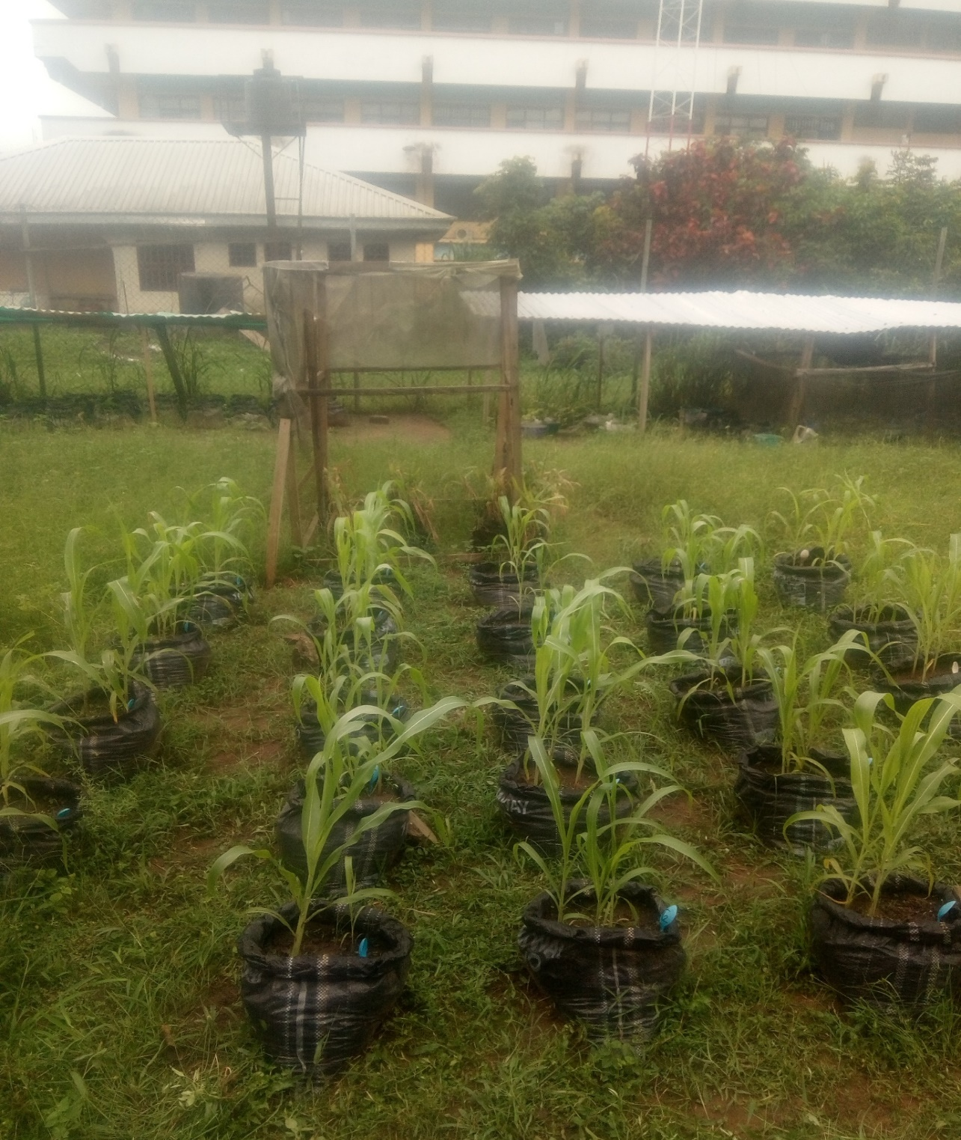

**Plate 1**: *Sorghum bicolor* planted in bags with different concentrations of pollutant

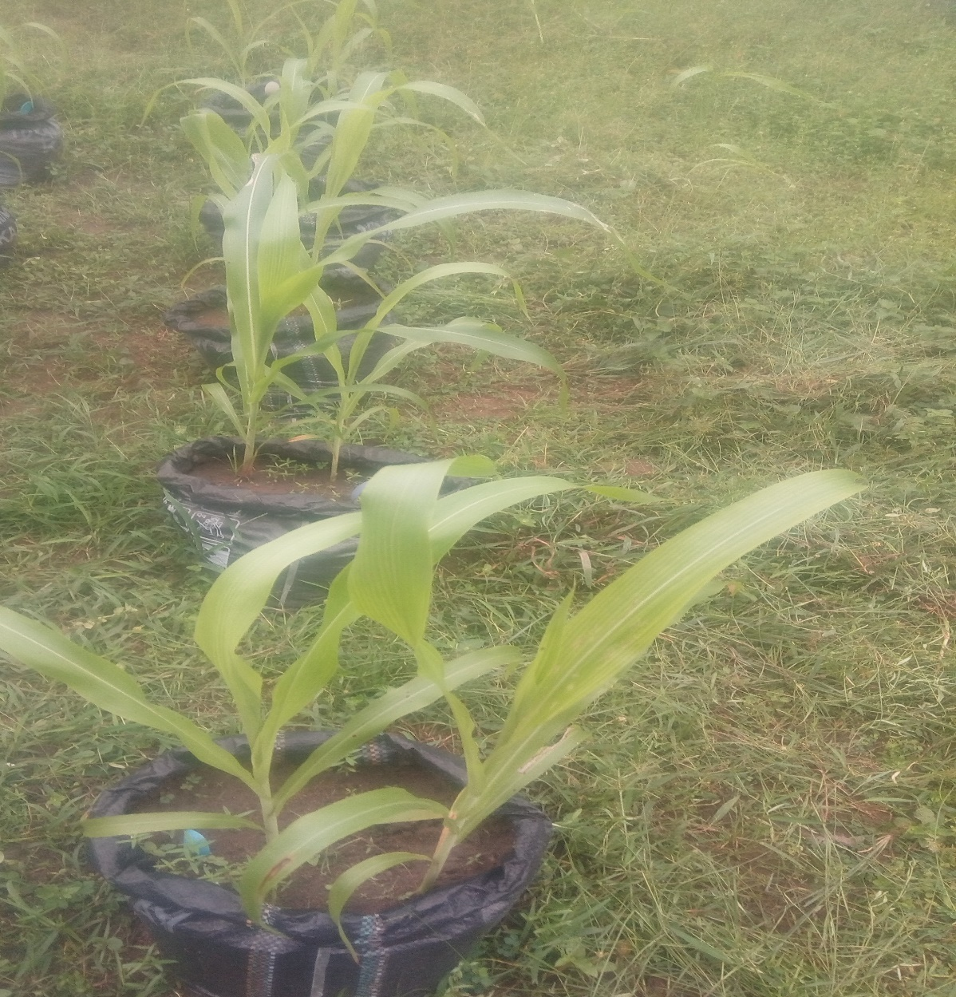

**Plate 2:** *Sorghum bicolor* treatment 0 at 4 weeks after planting

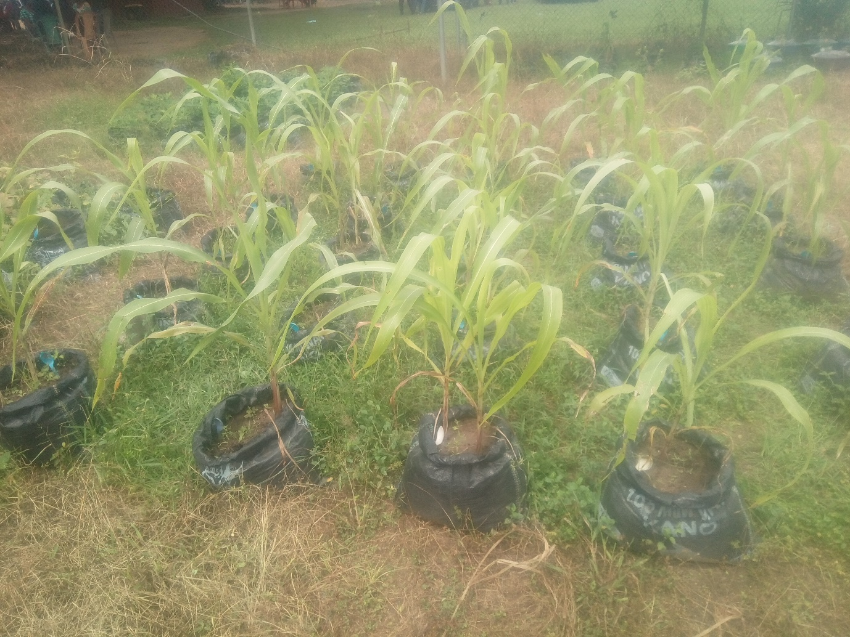

**Plate 3**: *Sorghum bicolor* planted in bags with different concentrations of pollutant